Artificial Intelligence

Antti Pikkuaho

Artificial Intelligence

Fall 2017

Information Processing Sciences

Oulu University of Applied Sciences

# Introduction

“The field of Artificial intelligence, or **AI**, attempts to understand intelligent entities” (Russell S.J & Norvig P. 1995. 3).

However unlike philosophy and psychology who share this aim, AI strives to build intelligent entities as well. The study of AI can be both interesting and useful, many impressive products have been produced by the study of AI. (Russell S.J & Norvig P. 1995. 3.)

The research of AI has benefited from the study of researchers from multiple fields that study intelligence before the establishment of the field of artificial intelligence. Namely philosophers who made the idea of an AI conceivable by proposing that the mind is in some ways like a machine. Mathematicians who provided the tools to manipulate statements of logical certainty and probabilistic statements of uncertain nature. Psychologists who strengthened the idea that humans and other animals can be thought of as information processing machines. Linguists that showed that language can be used in this model. Computer engineering provided the artifact that makes AI applications possible. (Russell S.J & Norvig P. 1995. 27.)

The field of Artificial Intelligence concerns itself with one of the ultimate puzzles: How is it possible that a brain can perceive, understand, predict and manipulate a world that is far more complex than it itself? How do we build something that can achieve such a task? Researchers of AI have solid evidence that making something like that is possible, unlike some other sci-fi sounding researches. (Russell S.J & Norvig P. 1995. 3.)

Russell and Norvig use a table provided in figure 1 to categorize 8 popular definitions of artificial intelligence into four distinct ways of thinking about AI. This gives four possible goals to pursue when researching artificial intelligence. Historically all four approaches have been followed. Tension exists between those approaches centered around humans and the ones centered around rationality. The truth however is that each direction has provided valuable insight. (1995. 4-5.)

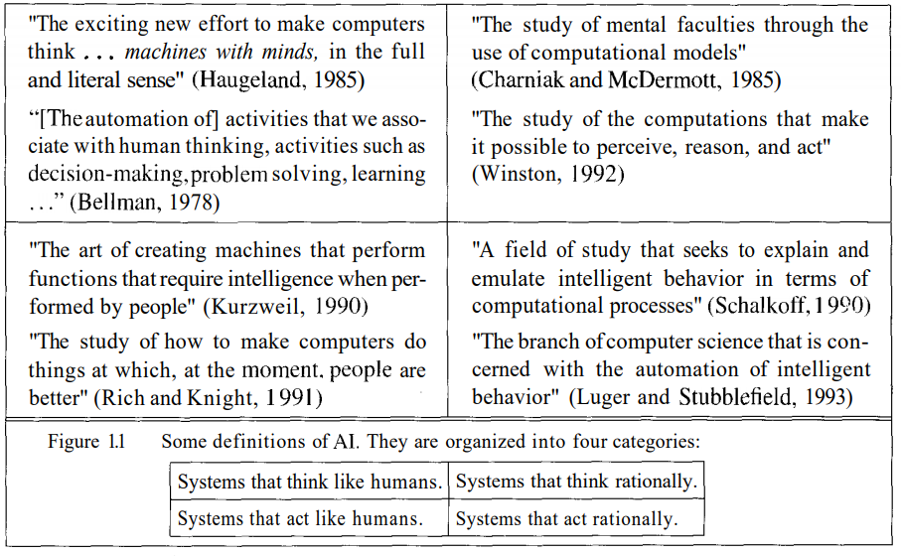FIGURE 1. Russell’s and Norvig’s categorization of AI definitions (1995. 5).

In their book, Russel and Norvig proposes that you need to ask yourself whether or not you are concerned with thinking or behavior? Are you researching or working on AI to model humans or are you working from an ideal standard? They take on the view that intelligence is concerned with rational action and that an **intelligent agent** takes the best possible action. (1995. 27.)

# Agents

An **agent** is anything that perceives it’s environment and acts upon that environment through effectors. An agent is intelligent when it **knows** things, does the right thing that causes it to be successful as determined by a **performance measure** done by an outsider. The agent must carry out his **actions** rationally, but not omnisciently since an agent cannot know the actual outcomes of his actions. Rationality is concerned with expected success given what has been perceived. Everything the agent has perceived so far is called a **percept sequence.** Therefore an ideal **rational agent** can be defined as:

*“For each possible percept sequence, an ideal rational agent should do whatever action is expected to maximize its performance measure, on the basis of the evidence provided by the percept sequence and whatever built-in knowledge the agent has. “*

(Russell S.J & Norvig P. 1995. 31-33.)

One thing to consider more is the built-in knowledge part. If the actions of the agent can be reduced to being based on it’s pre-existing knowledge and to ignore it percepts, then the agent lacks **autonomy**. An agent’s behavior can be based on experience, received and built from percepts, and built-in knowledge that helps it operate in a certain environment. Then that system is autonomous if it’s behavior *is determined by it’s own experience.* However we cannot expect a system to be autonomous with little to no experience, therefore it is helpful to provide an **artificial intelligent agent** with some initial knowledge as well as the ability to learn, so that it doesn’t have to stumble around randomly gathering experience. A truly autonomous intelligent agent should be able to adapt, given sufficient time, and not fail to operate when it’s built-in assumptions hold. (Russell S.J & Norvig P. 1995. 35.)

The job of the AI field is to create an agent program that functions from percepts to actions. This program would most likely run on a computing device, an architecture. Therefore AI is concerned with creating an agent that can be summed up as. “Agent = Architecture + program”. The environment which the agent will inhabit does not matter. Agents can be made to function in an “artificial” environments as well as “real ones”. One example of an agent in an artificial environment is a **software agent** that could be designed to fly a plane in a flight simulator for example**.** (Russell S.J & Norvig P. 1995. 35-36.)

# Artificial intelligence in games

Pac-Man (1979) is the first popular game with any sort of AI. Pac-Man relied on an AI technique called a **state machine**. That was as complex as it got for a long time, until 1997 when Goldeneye 007 was released. It added a **sense simulation system**, the AI could perceive it’s ‘colleagues’ and would notice their death for example. **Pathfinding** was noticed widely for the first time when Warcraft was released in 1994. In Warhammer: Dark Omen (1998) people saw **formation motion** in action. Some games made the point of their game the AI of the game. Those games, like ‘The Sims’ and ‘Black and White’, utilized a **neural network**-based brain.

(Millington I & Funge J. 2016, chapter 1.)

In games, those techniques and others are all still in use, some games don’t require anything more complex than a state machine. It is enough to satisfy the three basic needs of modern games: The ability to move characters, - to make decisions, - to think tactically. (Millington I & Funge J. 2016, chapter 1.)

Millington and Funge provide a consistent structure to understand game AI. It splits the AI into three sections: movement, decision making and strategy. Around those elements is a whole additional infrastructure. This model is illustrated in figure 2.

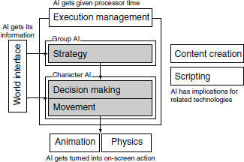  
FIGURE 2. The Game AI Model as provided by Millington and Funge (2016,chapter 1).

References

Millington I & Funge J. 2016. Artificial Intelligence for Games, 2nd Edition. Cited 8.1.2018. Internal Source, https://www.safaribooksonline.com/library/view/artificial-intelligence-for/9780123747310/

Russell S.J & Norvig P. 1995. Artificial Intelligence – A Modern Approach. Eaglewood Cliffs, New Jersey: Prentice Hall